Retail Pro V9 STADIS Plugin

# Installation

1. Add workstation settings to the STADIS database InstallationSetting table.
   1. Get file PluginSettings.txt from P:\Projects\ StadisRProV9Plugin\Doc.
   2. The file contains SQL INSERT statements for the settings. Change the SettingValues to the desired settings.
   3. Change the ComponentName from “StadisWS” to a vendor or group-specific name such as “AramarkWS”. This allows us to have different plugin settings for different vendors at a site.
   4. Execute the statements in SSMS to add the records.
2. Install StadisRProV9Plugin.msi to a work directory.
3. Edit StadisRProV9Plugin.dll.config.
   1. Change “StadisWebServiceURL” to point to correct web location.
   2. Change “InstallationSettingComponent” to the ComponentName used in Step 1.
4. Copy files to the workstation Retail Pro plugin directory, usually C:\RetailPro9\Plugins.

# Settings

The V8 plugin stored all settings in an ini file. The V9 plugin stores settings that are the same for all of a vendor’s workstations, or for large groups within a vendor’s workstations, in the Stadis database InstallationSetting table. For instance, all of Aramark might have the same settings, or Retail might have different settings from Food & Beverage.

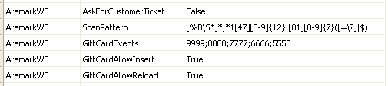

Only the handful of settings that are specific to the workstation are stored locally, such as UserID, Password, the URL of the Web Service, and the ComponentName corresponding to the set of InstallationSettings that are to be loaded for this workstation. The V8 plugin used a standalone configuration program to change settings. The V9 plugin uses Retail Pro’s WS Preferences:

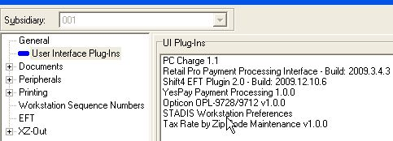

Double-clicking on “STADIS Workstation Preferences” brings up this screen:

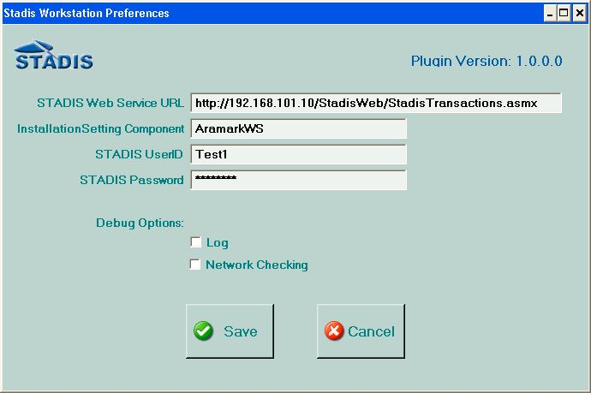

The V8 plugin stored the settings in an ini file. The V9 plugin uses a .Net settings file. The first time the plugin executes, the settings file doesn’t exist. .Net takes the default values from StadisRProV9Plugin.dll.config and creates it. It is an XML file named user.config located in C:\Documents and Settings\<user name>\Local Settings\Application Data\Retail_Pro_International,\DefaultDomain_Path_<numbers>\<release>\.

**After the first time the plugin is run, changing the values in StadisRProV9Plugin.dll.config has no effect on the settings.** StadisRProV9Plugin.dll.config is only a template. This means that new versions of the plugin can be copied in without overwriting the local settings. The settings have to be changed through WS Preferences or by editing user.config.